Agenda Item 9 g) Recycled Street Furniture
In December 2020 the Council successfully made an application to County Cllr Webber’s Cllr Priority Fund. The total amount was for £3k ex VAT made up as follows:
- Plants, tools, bug houses, etc. for the Wildlife Group - £1,151.32
- Recycled plastic furniture comprising Dale benches and possibly Ipstone Planters to a total value of £1,848.68 from TDP Derbyshire https://www.tdp.co.uk/product-category/seats-and-benches/ -

Options for Brown ‘Dale’ recycled plastic benches:
The recycled plastic outdoor Dale bench is made from 100% recycled plastic waste. Supplied fully assembled.

Options:
Length - 1200mm - £384.74 Price shown includes VAT (Net amount is £320.62), or
Length - 1500mm - £449.17 Price shown includes VAT (Net amount is £374.31), or
Length - 1800mm - £542.28 Price shown includes VAT (Net amount is £451.90)

Estimated delivery date is 11/01/22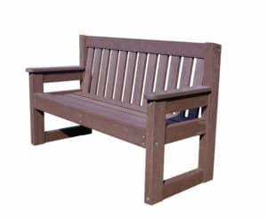
I recommend that the benches be fixed into the ground.
Anchor Kits
These are added security against theft and can be supplied with anti vandal screw options.
Hard ground anchor kits - £25.70 each
Soft ground anchor kits - £75.20 each

The Ipstone brown recycled plastic planters
The Ipstone heavy duty recycled plastic planters are supplied fully assembled

£255.86
Price shown includes VAT (Net amount is £213.22)

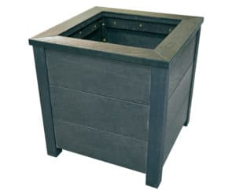

WEIGHT | 29 kg
DIMENSIONS | L500 x W500 x H525 (mm)
COLOUR OPTIONS | Black, Brown
WEIGHT | 29kg
HEIGHT | 525mm
WIDTH | 500mm
DEPTH | 500mm

Estimated delivery date is 11/01/22
Delivery would be free.
Cllr McAleavey called the company to check some technical details and he subsequently reported the following:
‘TDP are a family-run business in rural Derbyshire and their small workforce manufactures very good products with very competitive sales prices…….
Supplies from their raw materials manufacturers have been subject to price increases during the year and TDP have recently been notified of further increases at the end of 2021…….
Given an order of the size that we were considering, they would offer us a 5% discount.
However, as the numbers stand, we would still be over budget.
If we can 'subsidise' the purchases to cover the price increases (terms & conditions of the grant permitting) we could just go ahead and confirm the order.
The value of the 2020 quotation was £1848.68 so still scope for different combinations if we have to stick to that figure.
However, I would like us to consider other options.
The 1200mm benches are a 1+1 person size and, even under non-covid social distancing, may be less popular with, say, single individual users.
The 1500mm versions would be 1+1+1 person size, comfortable for 1s or 2s or 3s.
Of course, switching to 1500mm would further increase the overall cost, but if we cannot increase the budget, an adjustment to the numbers of both benches and planters would help get around that.’

Recommendation:
That the PC buys:
2 x Ipstone planters = total cost £426.44
4 x Dale benches sized 1500 = total cost £1,497.24
4 x fixings for soft ground = total cost £300.80
Total Cost: £2,224.48 less 5% (£111.224) = £2,113.26
Funded as follows:
Cllr Community grant £1,848.68 (Planters and benches)
PC funds £264.58 (anti theft-fixings for the benches.

LMW
08/11/2021

