Walk 4
5.7 kms
Red trail (Squirrel)
Countryside walk, mainly along footpaths, also going along the concrete road. A moderate walk as there are some kissing gates and other gates to navigate and some steps that will require a buggy to be carried. Can be muddy in wet weather. This takes you to the gravel pits, now a nature reserve with a lake populated by Swans, Geese and moorhens. If you are lucky you will see a Kingfisher as you cross the brook.
From the Village Green, turn left and go south towards Steventon. Turn left down the High Street.
In the 18th century housing in the village was centred mainly around a row of cottages down the left-hand side of High Street but on 16 April 1780 it was devastated by the Great Fire of Drayton. A bucket of embers from a cottage next to the Wheatsheaf was fanned by a strong wind into a blaze which crossed the narrow road and swept from one thatched roof to the next; round 30 cottages ere devasted. In an early example of crowd funding, a national appeal was established which raised the incredible sum of £3066. At the time the average agricultural wage was just 1s (5p) a day and so successful was the appeal that not only were the cottages rebuilt, but sufficient funds remained to build five alms-houses as well. It was probably the need for local building materials which stimulated the brickworks in the village, which were to become an important local industry.
On the right-hand side of the High street, was the relocated village school, built in 1875 but now converted into a house. (The one with the long windows). It had one large room divided by a partition, with high windows to ensure that the attention of the children should not be distracted. Heating and sanitation left much to be desired, and what would be considered gross overcrowding today was acceptable to the Victorians.
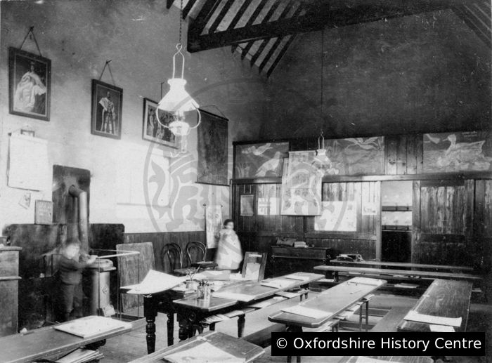
Photo of the interior of the school
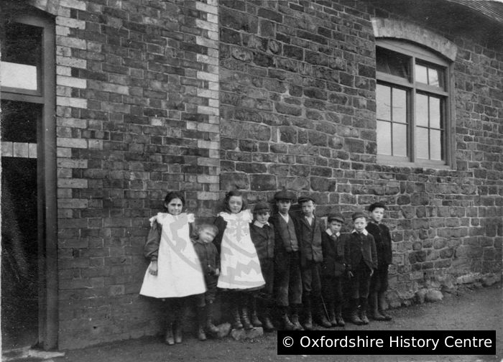
Photo showing children lined up outside the school
There used to be a shallow pond in front of the school through which farm wagons were drawn, in order to clean their wheels and the horses' hooves. The farm wagons/sledges were called drays after which dray horses are named. The village of Drayton takes its name from dray and ton meaning town or village.
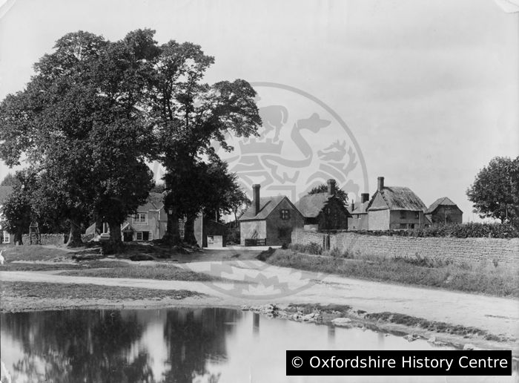
Photo of the village pond Drayton
A point of interest is that the grass verge you see on the left of the High Street used to be an open stream, running the length of the street, into which all the residents would discharge their effluent, before the days of plumbing. In other words, it was an open sewer. A sewage pipe was installed in the 1960’s, and the hole was filled in.
You will pass the Old Vicarage on your left.
The Old Vicarage, now converted into a large house, shows how comfortable a living was provided by the parish in former times. It is separated from the garden of The Grange by Love Lane, a raised footpath, walled on either side, which leads to Gravel Lane.
The Grange, set in large grounds, used to grow walnut trees commercially, this being commemorated throughout the village. (If you go to the end of the village, the Old Manor House on the right used to have the biggest walnut grove in the area).
No. 27, further down the road on the left, used to be a bakery, with the bread ovens and stable at the back of the house. The charred oak beams in the roof space, bear evidence of the great fire. They were re-used when the house was rebuilt, oak being an expensive wood. The bakery became a grocery in the 1950’s, and later a residential property.

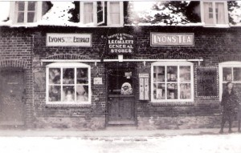
Photo from village website 29 High Street
Opposite no. 27 is Halls Close, once a working farm, owned by Farmer Halls. The timber framed house on the left corner was the old farmhouse, and the red brick house on the right, the dairy. Various barns at the back of the old farmyard are now converted into houses.
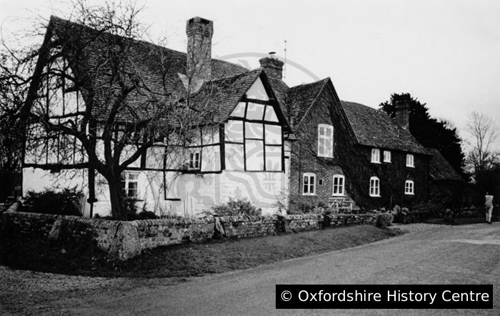
Photo of the farmhouse and old dairy

On to Church Lane, and on the corner, another bakery, Winters Corner, with the bread ovens situated in the wooden clad building behind the front room. The bakery used to supply New College, Oxford with bread, as much of the land in this area was owned by the college. The bakery later became a sweet shop in the 1950’s, run by the Winters family. Other trades in the High Street included wheelwrights and blacksmiths.

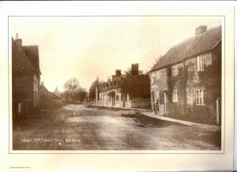
Photo of High Street showing Winters Corner

Turn left along Church Lane until you reach the churchyard on the right.
Opposite the church, where two houses now stand, was the old church hall, which was the social centre of the village. It was used for parties, weddings, wakes, receptions, dances, and even as a cinema.
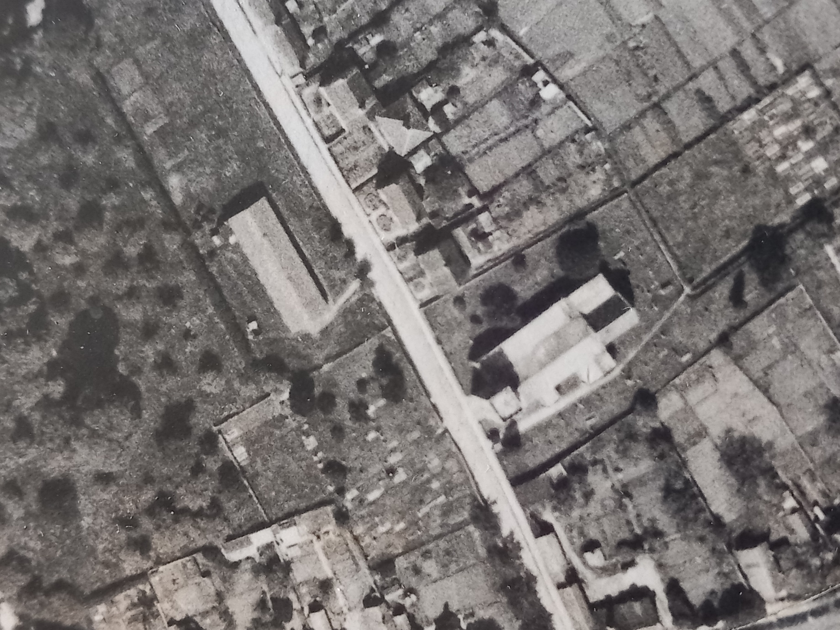
Aerial photo here of the old village hall opposite the church.

Go through the Lynch Gate.
The lynch gate is Drayton’s war memorial and is inscribed with the names of 30 men who died in both world wars and the Korean War. There is also a commemorative tablet in the paving for Sergeant Edward Mott who was awarded the VC in World War 1.
St Peter’s Church was originally a chapel, built between 1200 and 1300. All that is left of this is part of the south wall of the nave. The font also dates from this period.
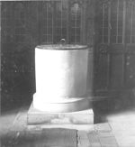
Photo of font

The north aisle and tower were added in the 15th century, and more was added in the 19th century. The first four bells were installed in 1552. Over the years however, they became cracked, and in the 1960s, had to be re-cast. This time, they made six bells and augmented the number to eight, ten years later. To this day, they are regarded as being the best bells in the area, and bell ringing competitions are held annually, with bell ringers competing from far and wide. The weathervane was erected in 1929 as a memorial to Mr. and Mrs. Henderson’s son, who was killed in the First World War.

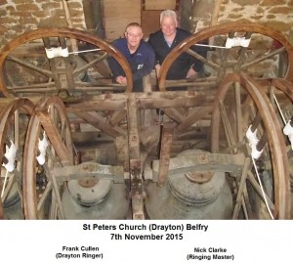
Photo showing the bells
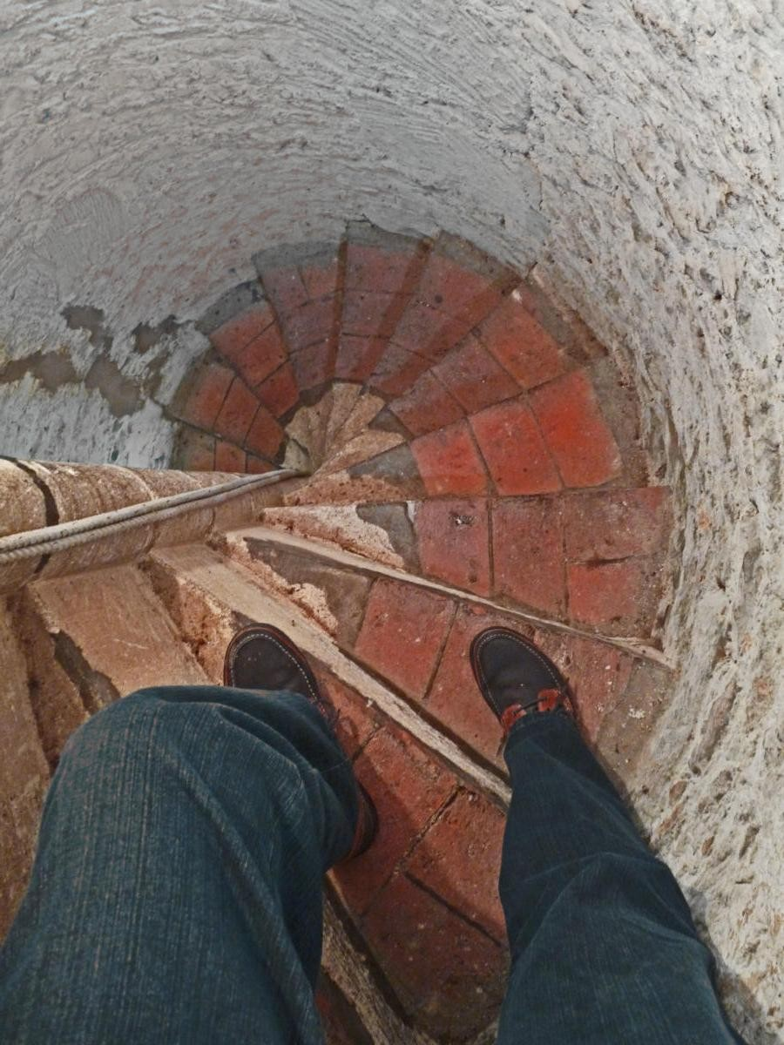
Photo showing the inside of the tower
Continue past the church and follow the path through a metal gate into the parish burial ground. Continue straight on until you reach a T-junction, where you turn left. After a short distance another path leads off to the right through a hedge and across a field towards farm buildings then through a gate diagonally across another field, reaching Gypsy Lane in the corner. Here you turn left.
Continue along Gypsy Lane for some distance until you reach the corner of a concrete road which runs straight down on the right for nearly half a mile. Take this road and just before it joins Peep-o-Day Lane there is a kissing gate into a nature reserve on your right. Follow the path through the gate as it winds diagonally back towards Drayton, past a lake on your right, through more gates and eventually, up some steps into Sutton Courtenay Road. Here you turn right for about 50 yards, and right again into the wide entrance of Gypsy Lane. Follow it past the farm buildings, ignore the kissing gate through which you came on the outward journey, but take the next path, a few yard further, on the left.
This leads past a builders’ yard into Sutton Wick Lane. Turn left again and once past the Millennium Green, this path divides the magnificent gardens of Lime Close before emerging in Henleys Lane.
Lime Close has Elizabethan origins and was a private school for ‘young ladies’ in the 18th and 19th centuries, a period when the education of girls was considered unnecessary. Now it is a private residence whose gardens, extending to five acres, are often open to the public as part of the National Garden Scheme.

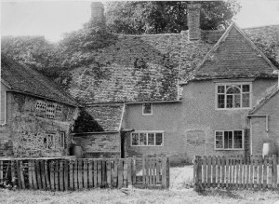
Photo of old house at Lime Close
There is a Wesleyan Chapel on the corner of Henleys Lane, built in 1870 and now converted into a modern home.

Cross the road, and to the right of the chapel, there is another footpath leading to Gravel Lane.
Emerging into Gravel Lane (named after the amount of gravel deposited in this area in the Ice Age) to your left is the back entrance to the Grange, another of Drayton’s fine old houses. It remains occupied by the same family who were originally tenant farmers of New College, Oxford, owners of much of North Berkshire until the 1700s (Drayton didn’t become part of Oxfordshire until 1974). Opposite it is the Caudwell Day Centre, used as a community hub by the village, as well as a development of social housing endowed by the family.
Walk up Gravel Lane, passed Thames Valley Saws, which was the site of the first hardware store in the village, before Vickery’s was built, and back to the green.

