Walk 3

1.8 kms

Green trail (Hedgehog)

An accessible easy walk, along footpaths taking in the conservation area, the Millennium Green and Sutton Wick Pond. There can be some puddles in mid-winter but this should be accessible for all.

Start at the Village Green.

Face the map with the Baptist Church behind you. This church was established in 1834 and still has an active role in the village.

To the left of the notice board are two areas of grass, dissected by a road leading to what used to be a working farm belonging to the Earl of Plymouth Estates. The Georgian house to the left used to be the old farmhouse, and the other buildings were barns used both for cattle and to store grain. The large barn in front of you behind the hedge was also a part of the farm, now converted into two homes.

There used to be a well in the middle of the green, which before the days of plumbing, was an important source of water for villagers and was one of the few in the entire region never to dry up. In the 18th century, owing to a severe drought, the men of Drayton were forced to guard this well, against neighbouring villagers, who came with buckets to steal the water. According to legend, a battle ensued between them, water being a precious commodity in those days, and presumably the Drayton men won.

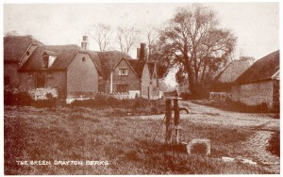
Photo of the well

Walk straight down Gravel Lane. You will pass Thames Valley Saw Service, which used to be a Nissan hut in the 60’s, owned by Bob Winter, the builder. He later rebuilt it for use as a storage for his tools, but as everyone in the village came to ask him to sell them his stock, he decided to build a Hardware Shop in place of the old cottage near the present Post Office, which was later taken over by Arthur Vickery and his son Lawrence. Thames Valley Saws, a family run firm, established their business in the 70’s and still rent the land from the Winter family.

Go to the end of Gravel Lane and take the footpath which will take you to Henleys Lane. You will pass the Grange on the right, behind which was one of the walnut groves, for which the village was well known. Walnuts were an important commercial business in the 19th century, hance the reference to walnuts throughout the village.

As you walk along the footpath, the house on the left before the end, was once two farm workers' cottages with pig styes running alongside them.

When you emerge from the footpath, you will see a Victorian standpipe, which was vital to villagers in times of drought, as only the older cottages had wells.
.
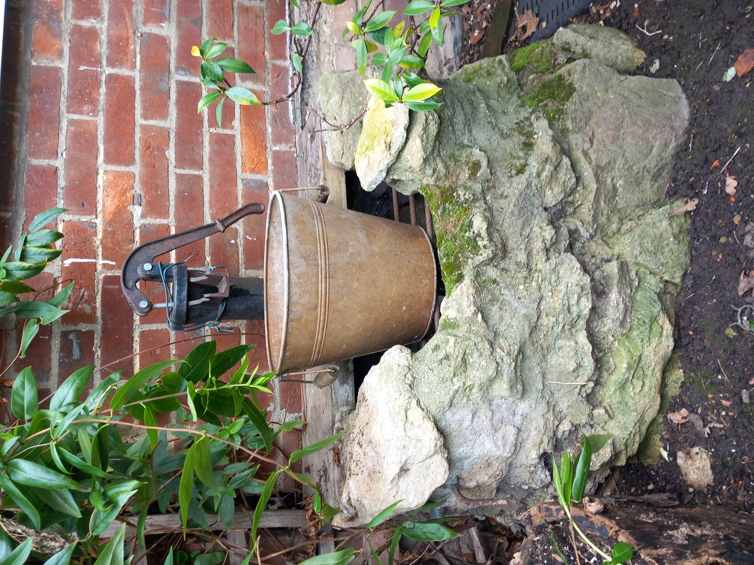

At the end of the footpath turn right onto Henleys Lane and you will see the Old Chapel, which was once a place of worship, but fell into disrepair before conversion into a private residence in 2017. To the right of the chapel, take the footpath to Sutton Wick.

Walk straight along the footpath and take the first footpath off to the left. This takes you onto the Millennium Green.
You will pass alongside beautiful gardens belonging to Lime Close, a Medieval house, once a private boarding school “for young ladies”.

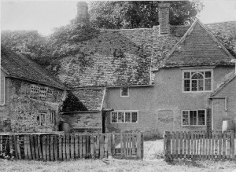
Photo of the old house at Lime Close

The Millennium Green was purchased by the village, from the National Trust as part of the 2000 Millennium Greens Initiative and was financed by the National Lottery Fund. It had previously been a meadow used for grazing cattle. Note the circle of walnut trees in the center, which together with many of the trees round the periphery, were planted as part of the development of the Millennium Geen. The walnut trees were planted to commemorate the commercial importance of walnuts to the village in the 18th and 19th centuries.

When you have passed the pond, take the right-hand footpath to start to circle the Millennium Green.

Take the first turning out of the Green to your right and into Sutton wick Lane, up to the pond on your left.

Sutton Wick was once a separate hamlet and in spite of being some distance away, legally, a part of Sutton Courtenay. It joined Drayton in 1934.

You will pass a board commemorating the tragic crash on 5 March 1957 of a Beverley transport airplane which had just taken off from RAF Abingdon. Eighteen crew and eight RAF police dogs were killed as well as two residents of Sutton Wick; two cottages were also destroyed.


As you walk along, you will pass homes converted from a barn belonging to Sutton Wick Farmhouse on your left.

Turn left just before the pond and return towards the Millennium Green past a large, listed Georgian House dating from 1712.

Walk onto the Millennium Green and take the path to the right around the Green. You will pass an orchard of heritage apple trees, of the sort indigenous to the area before the introduction of modern varieties. It was planted as part of the design for the Millennium Green.

Take the first turning off the Green to the right and go along the footpath between the field of horses and the listed building, Old Lodge.

You come to Henleys Lane at the end. Straight ahead you will see an old farmworker’s cottage. Turn right where you will see Pusey Cottage ahead to your right. This 17C thatched cottage is all that remains of Pusey Farm, which used to cover a wide area up to Abingdon Road. Before you reach Pusey Cottage take the footpath to the left that goes up a gentle incline onto the former Manor Farm. Its kitchen garden once supplied the monks at Abingdon Abbey, until the abbey was destroyed during Henry VIII’s Dissolution of the Monasteries.

The path makes a circle of Manor Farm Green, but if you turn off at the top and down Abbott Close to your left, you will rejoin Gravel Lane.

Turn right and you will see the Village Green ahead and be back where you started.

Note the walnuts on the village green, which were installed by the Parish Council in 2018, to deter parking that was destroying the grass. Apart from acting as bollards, they also serve as a reminder of the walnut connection in the village.

