Walk 2
5.9 Km
Blue trail (Blackbird)
One incline over and back across the A34 otherwise flat. An interesting rural walk taking in a piece of industrial heritage. Can be muddy and a bit overgrown in places.

From the village green, cross over the road to the Post Office. This used to be a bakery, and later a general store, before conversion in the 60’s.

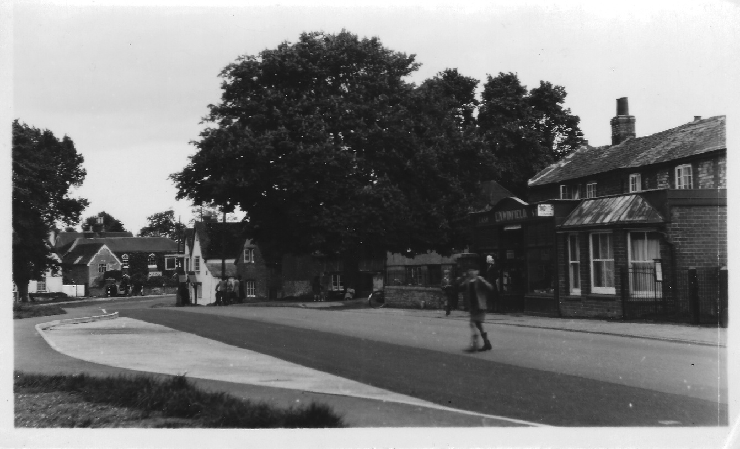
Photo of the Post Office

Walk past Vickery’s. This used to be an old cottage, but was rebuilt in the 60’s as an ironmonger’s, moved up from Gravel Lane.
You then pass the house that used to be the old post office.
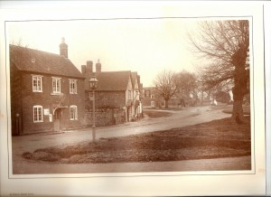
Photo of the Old Post Office and Wheatsheaf

Go past the Wheatsheaf (now Dosa Spices Restaurant). The Wheatsheaf dates back to the 16th century and it was from an adjacent cottage that the Great Fire of Drayton of 1780 began, devastating much of the centre of the village.

You now come to Mott Cottages, named after Edward Mott, a Drayton resident who was awarded the Victoria Cross in the First World War. On the opposite side of the road, you will see Gothic House with its mural of George & the Dragon on its gable; a former occupant was Charles Sykes, a sculptor who designed the ‘Spirit of Ecstasy’ emblem that used to adorn the radiators of Rolls Royce cars.

The walk then takes you down Kiln Lane, on the right. The area which is now 1960s housing was once Drayton Brickworks which in the early 1900s consisted of five claypits up to 40ft deep, and a waggon on rails for carrying the clay to the shed in which a steam engine drove machinery for pugging the clay (a process for ensuring consistency) and making wire-cuts. This important local industry manufactured bricks, tiles and drainpipes, and the kiln was also used for lime-burning (to produce plaster). Its products were transported to markets along the length of the nearby Wilts & Berks Canal. The deep reddish brick of many of Drayton’s older houses come from the brickworks.
Continue over Lockway (named after the canal) and across the A34 bridge. Immediately, you take the path to your left and parallel to the A34. Follow the path as it turns right across fields and past Drayton Copse until you come to the ditch, which is all that now remains of the Wilts & Berks Canal. Drayton Lock is fenced off.
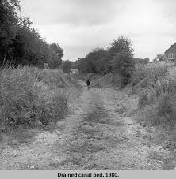
Photo of the disused canal near Abingdon
The canal opened in 1810, linking the Kennet & Avon Canal with the Thames at Abingdon. It was 52 miles long with 42 locks; its depth was 4ft 6in and it had a surface width of 27 ft. Each barge, 70ft long and 7ft broad, could carry about 25 tons of cargo. In 1837, when the canal was at its peak, 10,669 tons of Somerset coal were unloaded at the Abingdon wharf. In addition, flour, malt and corn were transported, as well as bricks, tiles and drainpipes from Drayton Brickworks. Competition from the railways caused its closure in 1914.

On the further side of the canal the path diverges; you take the right-hand route. Follow the canal until you come to a concrete road where you turn right again; this brings you back to the A34 bridge and eventually, to your starting point.

