Walk 1
Short walk 3.5 kms
Long walk 4.4 kms
Owl (purple trail)
From the Village Green, turn down High Street, opposite the Wheatsheaf (now the Dosa Spices Restaurant). At this location a tragedy unfolded on 16 April 1780. Some embers thrown out from a dwelling adjacent to the Wheatsheaf ignited in the strong breeze, crossed the narrow road and set fire to the thatched roofs of some 30 cottages lining the north side of High Street. The 16th century cruck cottage at the bottom of the street has survived, and remains thatched. The devastation gave rise to a national appeal which raised no less than £3066 – enough to rebuild the cottages and build five new alms houses as well.
When it is safe to do so, cross High Street, noting the high-roofed Victorian school, now converted into a house. You can still see the initials of former pupils carved around the door.
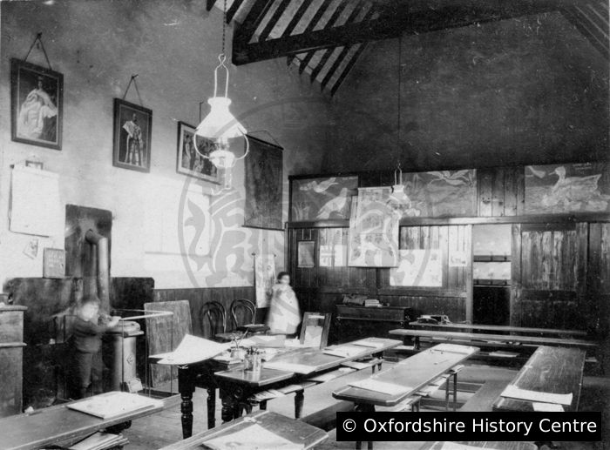
Photo of the interior of the school

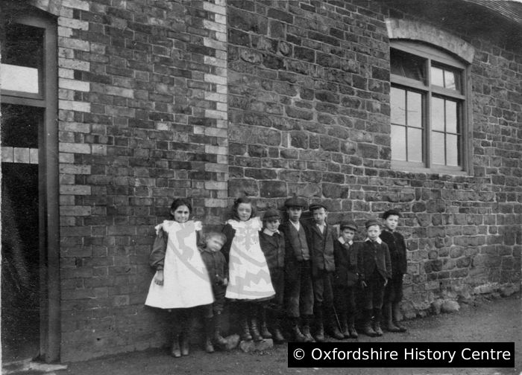
Children lined up outside the school

In the wide, green verge in front of it there used to be a shallow pond through which horse-drawn farm wagons were drawn in order to clean their wheels.
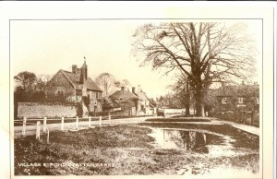
Carts pulled by farm horses were called drays, giving the name to Dray Horses. Ton is an old word for town or village. Hence the name Drayton.

Next to the site of the old pond is the aptly named Pond House and then you come to a tarmacked, pedestrian entrance into the Dovecote estate which you take, leading into Plough Lane.
Carry on along Plough Lane and, as the road turns left, you go right, through the gap in the hedge onto East Way. This track, which is almost straight, leads all the way to Sutton Courtenay and you follow it for some distance until you reach a metal kissing gate on the left. Before you get there, you will see the back of the Manor House across the fields on your left, parts of it originating from the Elizabethan period. The land to the south of the house was the site of the biggest walnut grove in the area and was a vital source of income for the landowner and villagers.
Go through the gate and follow the path alongside the hedge, over a bridge across a stream and continue until you come back to High Street. With care, descend the steps and cross the road onto the bridleway ahead. Follow this past the newly planted arboretum, part of the Lime Close gardens, turning left at the end and on to the Millennium Green.
Lime Close, also of Elizabethan origins, was a ‘school for young ladies’ in the 18th and 19th centuries, before the days when it was considered necessary to educate girls. A hoard of rusty thimbles and scissors, found beneath the floorboards there during recent alterations conjures up a picture of little girls laboriously stitching letters and verses into their samplers.
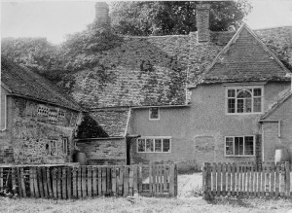
Photo of the house at Lime Close

The Millennium Green was created from land formerly owned by the National Trust and used as a meadow for grazing cattle. The pond, paths, most of the trees and the orchard of heritage apples were introduced as part of the design in the late 1990s. It features a low-walled gnomon which is, in effect, a large sundial. Note the central circle of walnut trees, planted as a reminder of the importance of the harvest of walnuts to the village from the 1700’s.
Walk clockwise around the Green until you come to the gap in the wall leading to Sutton Wick and on to the pond, popular with children for feeding the ducks and geese. Sutton Wick was part of Sutton Courtenay parish until 1934, when it joined Drayton. On 5 March 1957 it was the site of a terrible accident when a Beverley transport plane came down shortly after take-off from RAF Abingdon, killing 18 people.
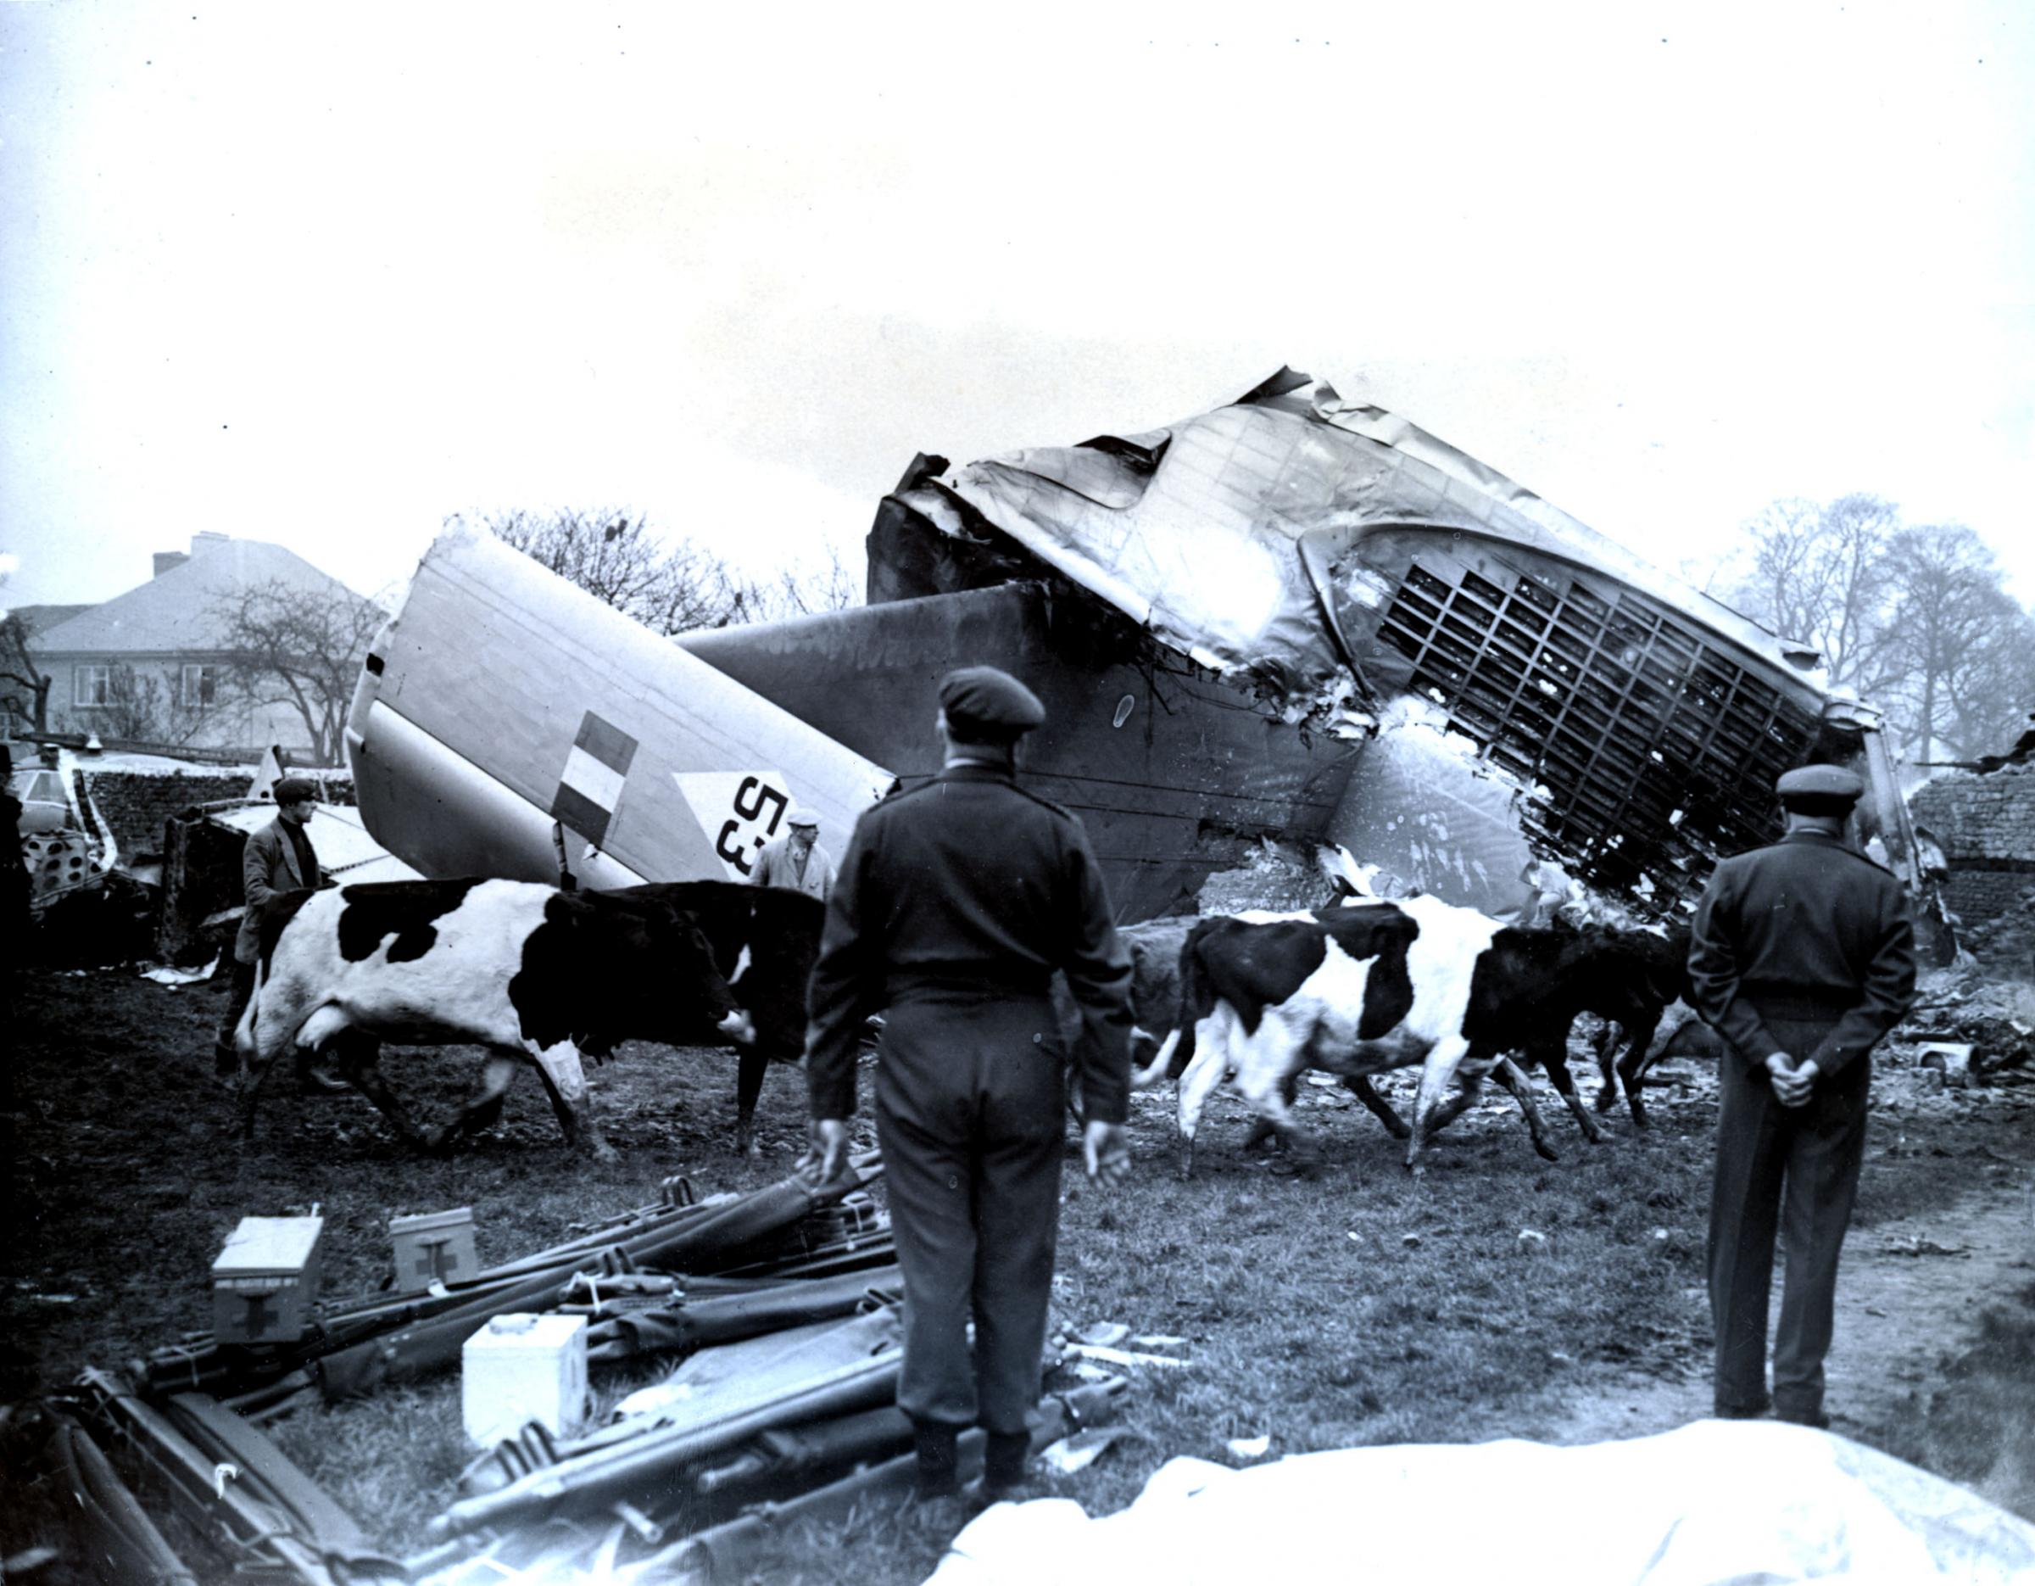
Photo of the Sutton Wick plane crash

Now you must decide whether to take the shorter or longer route back. The shorter route takes you back across the Green, clockwise again, and just before you reach the gnomon, down the path to Henleys Lane. Turn right and take the path up the slope onto the manor Farm estate. Until Henry VIII’s Dissolution of the Monasteries the produce of the farm was sent to Abingdon Abbey, and this ecclesiastical connection is remembered in the names of the roads on the estate.
Follow the path up to the main Abingdon Road and past the Red Lion, established in the 19th century, back to the Village Green.
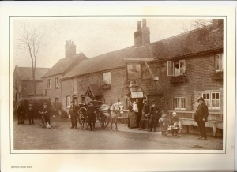
Photo of the Red Lion
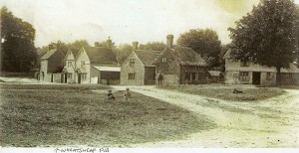
Photo of village green
The Longer Route takes up Sutton Wick Road to its junction with Abingdon Road. Cross over to Chestnut Drive and turn left at Holly Lane. A footpath to the right takes you in front of the houses facing the new sports facilities into Willow Way. A gap through the hedge takes you into Barrow Road, named after a Neolithic Long Barrow (burial place) which was located behind the sports field. Head back towards Drayton, past farm buildings and then right onto the tarmacked footpath into Corneville Road.
Halfway down Corneville Road is a path to the right; take it and follow it round with the school playing fields to your right, until you reach Abingdon Road again. Cross over the road and turn right past two business premises on the corner of Crabtree Lane.
In the 1900s a laundry was located here.
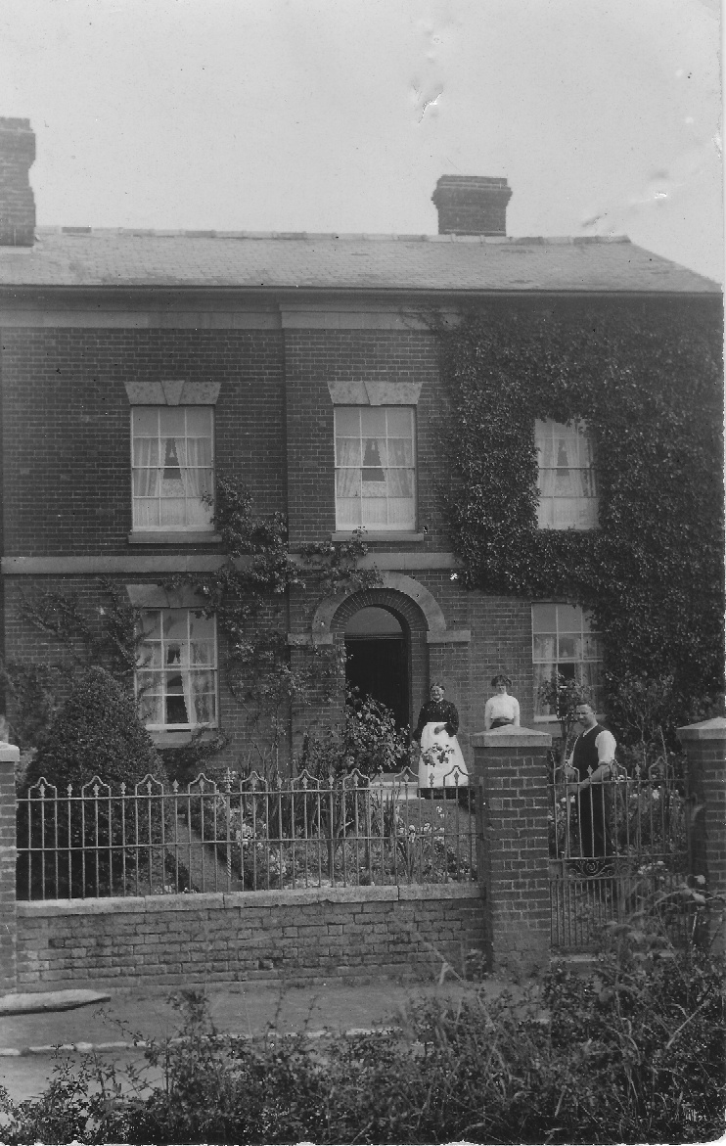
It later had an extension built on the front, and became a butcher shop with a greengrocer’s next door; with the frontage you see today. Later occupants included a television repair shop and a supplier of exotic pets.
There used to a petrol station on the corner of Cornville Road, opposite, when the Abingdon Road was the old A34, and the main route from the south coast to the north.
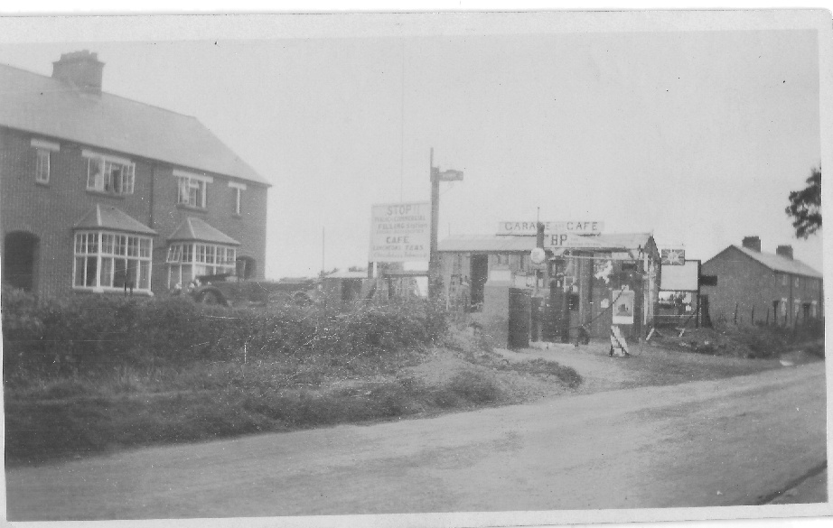
Photo of the Petrol Station
You continue down Abingdon Road, then turn left down Henleys lane. Just past the thatched Pusey Cottage there is a path on your right, up to the Manor Farm Estate, which you take. Cross onto Prior Drive and then down Monks Close. Just before you join Gravel Lane (named after the large deposits of gravel left by the glaciers in the Ice Age), there is a cottage on your right which used to be part of Manor Farm. There you will see a large collection of horseshoes which a previous occupant found while ploughing the fields. Turn right and you are back on the Village Green.

